How to Use GeoGebra to Solve Problems in Calculus
Example: Critical Points

Let’s say we wanted to identify the minimum point on the curve $y=x^{2}-6x+5$using GeoGebra.

In order to find the maximum and minimum, we want to find the point on the curve where the rate of change, or derivative, is equal to zero.

- Open up Geogebra, on the bottom left where it says “Input:” type in the following then hit enter.
$f(x)=x^{2}-6x+5$

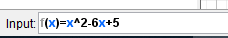
By entering this function, the application will recognize your function as “f” and generate the corresponding curve.

2. In the same input space on the bottom, type in the following:
Derivative[f]

Entering this input will present you with the derivative of your function “f” on the left, as
well as a graphic representation. Your page should look like this:
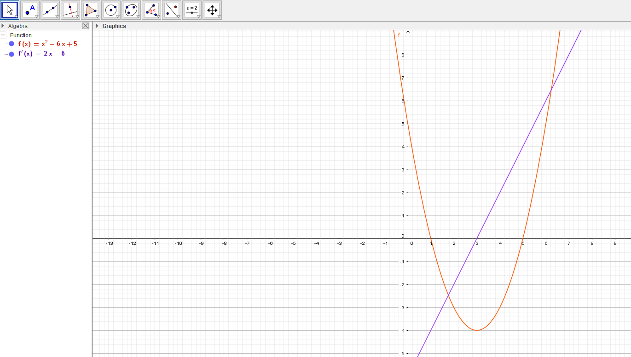
3. On the top left corner, find the “point” button, click the drop down menu and click on “intersect”
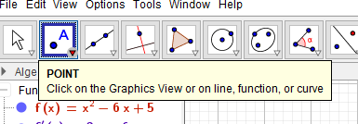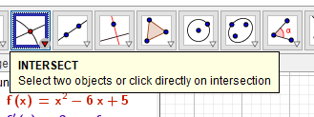

4. Since we want to find where the rate of change (derivative) is equal to zero, after we select the intersect button, click on the slope line that represents our derivative, and the x-axis where x=0.
This will give us our minimum x value of our curve.

What is the minimum x value of our curve? _____(___,_0_)_____

5. Now that we discovered the x value to our minimum point of the curve, now we want to use GeoGebra to find the y value. On the top left, select the button that represents “perpendicular line”
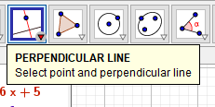

6. Click on the point of intersection “A” and the x-axis where x=0 to generate a perpendicular line going through our point and perpendicular to the x-axis:
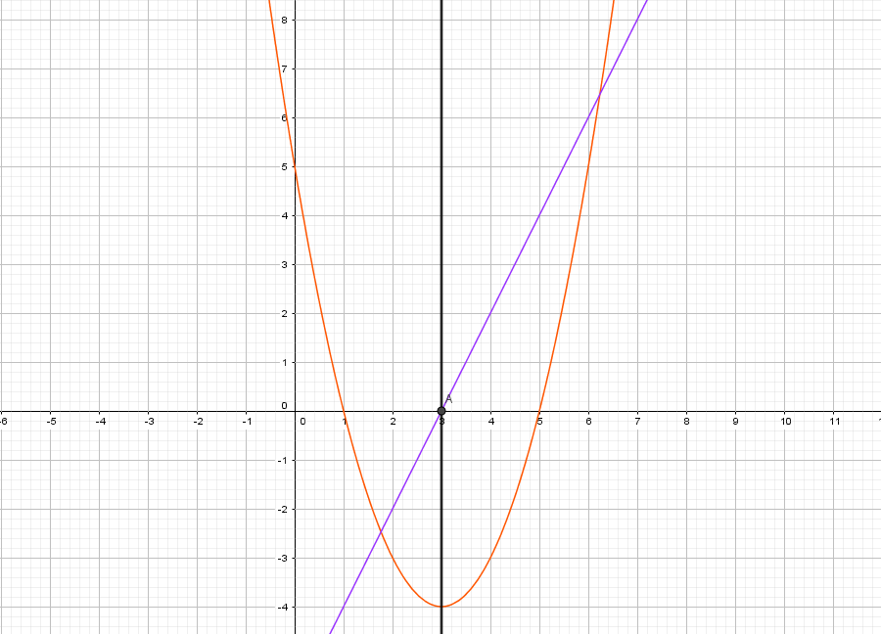
7. Finally, to determine our y coordinate for our minimum, click on the intersect button, then click where the perpendicular line and the bottom of the curve meet:
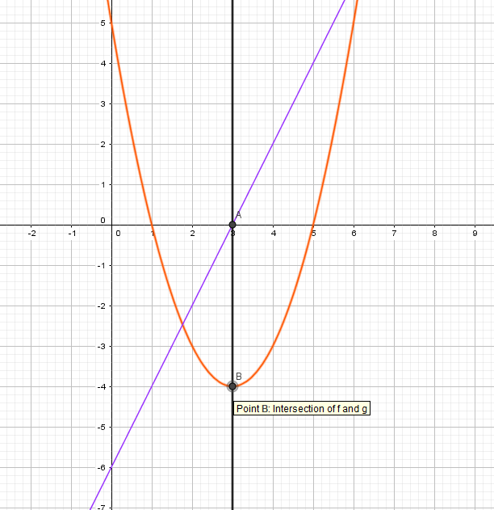
On the left, the point labeled “B” is our minimum point of the curve.

What is the minimum of the function?_____(____,____)______

Note: The same steps may be used to find the maximum of a curve in Geogebra.

Let’s say we were given a new function, $x^{3}+x^{2}-4x-1$, where we wanted to determine the roots, maximum and minimum, and the point of inflection.

Review: What is the point of inflection? __________________________________________

- Enter your function on the bottom input. Your page should look like the following photo:
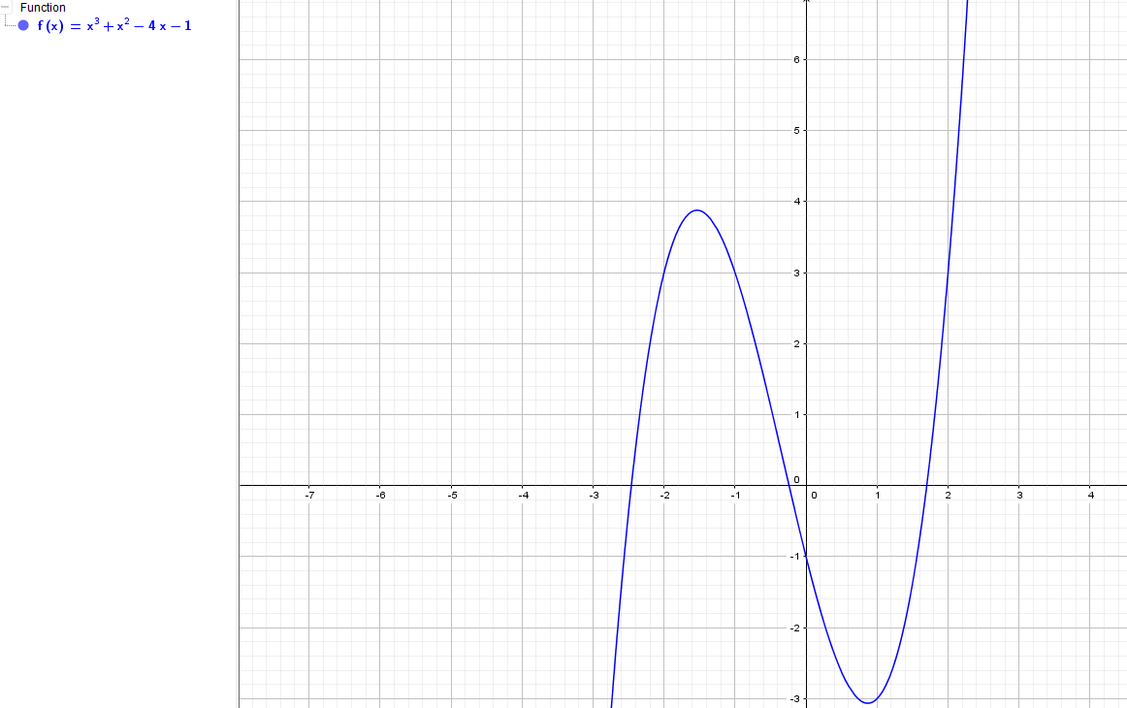

2. First, to find the roots of the graph type in the following to the input bar and click enter:
Root[f(x)]

Your three points labeled ‘a’, ‘b’ and ‘c’ will be given on the left side of your screen and indicated as points on the graph.

What are your three points?
A:_____
B:_____
C:_____

3. Now we would like to find our extrema, or our maximum and minimum points. To do this, go to the input bar and type in the following and hit enter:

Extremum[f(x)]
Your maximum and minimum points will be labeled ‘d’ and ‘e’ on the left side of your screen, and indicated as points on your curve.

What are your maximum and minimum points?
Max:_____
Min:_____

4. Finally, let’s find our point of inflection. To do this, type the following into your input bar and hit enter:
InflectionPoint[f(x)]

Your point of inflection will be labeled ‘f’ on the left hand side of your screen and indicated as a point on the graph.

What is the point of inflection?
__________

